James Moran

Amazing Archery! Design, Implementation Testing and Source Script

AE2 – Supplementary Report

Includes: Design, Implementation, Testing and Source Script

Contents

Design 2

Implementation 2

Testing 2

Source Script 2

# Design

## Basic Requirements

The ‘user stories’ for such requirements, are shown below:

* As a user, I want to be able to see the target down range, so I can aim at it
* As a user, I want to be able to aim my bow by moving my phone, so that aiming is simple and interactive.
* As a user, I want to be able to adjust the power of each shoot by pulling down the on the screen.
* As a user, I want to be able to hit the target and receive points for hitting it.
* As a user, I want to see my arrows flying in an arc so that is mimics real arrows in flight.
* As a user, I want to see a score board on the screen so that I can keep track of my score as I play.
* As a user, I want to be able to pause the game at any time.
* As a user, I want to be able to see a high score list so that I know how well I'm doing compared to my previous scores.
* As a user, I want to be able to see the student's name in the corner of the screen at all times so that I can give credit to the student.
* As a user, I want to be able to see a menu upon starting that game.
* As a user, I want to be able to pick from at least 2 shooting ranges.

For this set of ‘user stories’, the design for each ‘user story’ (from the top), is as follows:

### See the Target (so the Player can aim at it)

This project will use the Unity engine and the perspective for the Player; Is a first-person perspective, looking straight towards the target.

A bitmap for the target (so that the Player can see it), will get shown in the scene, allowing the Player to see a target. A flowchart representation of such, is shown below:

I presume that I can simply drag and drop the bitmap into the scene.

The Player (whom would see the target whilst the game is playing), is not present in the game at this stage of design, their design is detailed in the next ‘user story’:

### Allow the Player to Aim Their Bow (by moving their phone)

For this ‘user story’, at a top level, the design for such is as follows:



However, if the phone’s Orientation has not altered since the last pass of this routine, the point of aim will not require adjustment to match the phone’s Orientation, as this would not procure any results for the Player to see. This detail is delved into, in the pseudocode below:

AdjustAimPoint

{

Vector3 PhoneOrientation = GetPhoneOrientation();

If (PhoneOrientation != LastPhoneOrientation)

{

AdjustAimPointForPhoneOrientation(PhoneOrientation);

}

LastPhoneOrientation = PhoneOrientation;

}

Of course, the Player’s aim is the point of aim getting adjusted, which will require Player Character in game (with a 1st person perspective). They will also require a target reticle, to show their current point of aim, in the Unity Editor, the Player Character would receive construction as so:



The HUD for the Player Character, at this stage in design, appears as such:

The pseudocode for AdjustAimPointForPhoneOrientation(Vector3 PhoneOrientation) is as such:

AdjustAimPointForPhoneOrientation(Vector3 PhoneOrientation)

{

/**

Only analyze rotation around the X and Z axes

*/

// Get the difference in orientation, for the phone’s X-axis (pitch):

float UpDownDirectionMagnitude = PhoneOrientation.x – LastPhoneOrientation.x;

// Move the crosshair up if this difference is positive, or down if the difference is negative:

Player.MoveCrosshairY(UpDownDirectionMagnitude);

// Get the difference in orientation, for the phone’s Z-axis (Roll):

float RightLeftDirectionMagnitude = PhoneOrientation.z – LastPhoneOrientation.z;

// Move the crosshair to the right if this difference is positive, or to the left if the difference is

// negative:

Player.MoveCrosshairZ(RightLeftDirectionMagnitude);

}

### Allow the Player to Adjust the Power of Each Shot (by dragging a touch input instrument (such as their finger), downwards across the screen)

If the Player presses and holds their touch input instrument at a certain point on the screen, for greater than a certain quantity of time, prepare to modify their shot’s power level. Pseudocode to describe such, as shown below:

ModifyShotPowerLevel(Vector2 InitialContactPoint)

{

// Detect drag movement:

}

# Implementation

## Basic Requirements

### See the Target (so the Player can aim at it)

First I will create the respective bitmap (so the Player can aim at it). I will use Microsoft Paint for this.

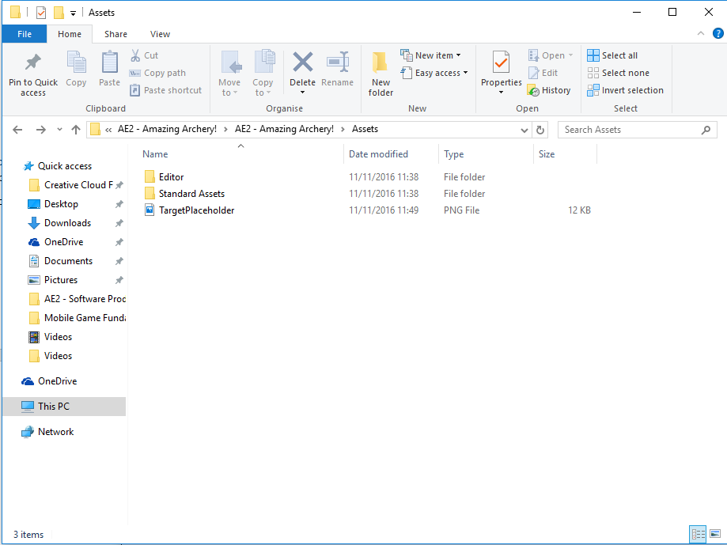After this, I copy the respective bitmap into the assets folder (via the Windows Explorer):

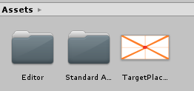I can also see this in the Unity folder navigation system:

However, I am unable to simply drag and drop this bitmap into the scene (a 🚫 symbol appears), so I create a plane (by pressing the right-mouse button, whilst the focus is on the hierarchy panel of the Unity editor, then in respective context menu: 3D Object->Plane), then drag and drop the bitmap onto it, which is successful (but to see the object, a camera and a light were required, for a viewing perspective and a respective light source, after putting these into the scene in a similar manner to the Plane, as well as altering the transform of all these game objects…):

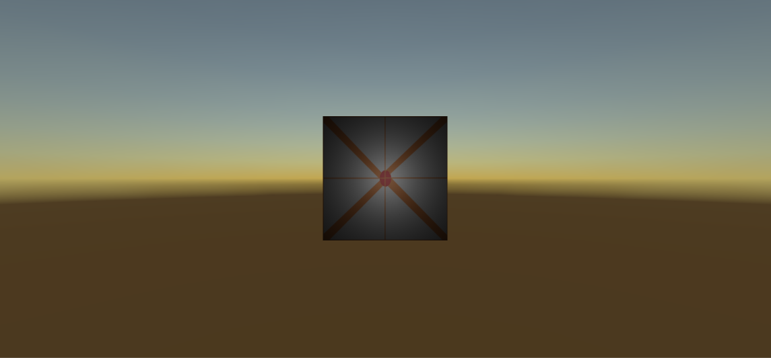

So, with the aforementioned alterations to the initial implementation logic; it is now possible to see a target in the game.

# Testing

# Source Script